Monster Hunter: World

GD08 Cloud

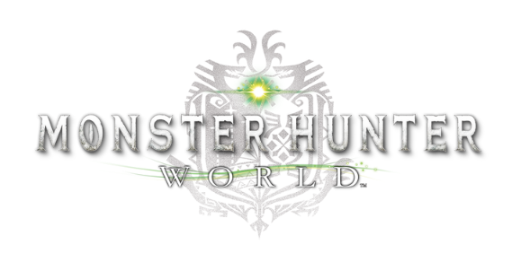

# Physics – Player Motion – Motion in Air

*All weapons have different* ***motions in air*** *and on the ground. In this work players have a lot of unique motions in the air both when weapon is sheathed or with weapon drawn.*

* All the motions in air and their features when weapon is sheathed:

1. Aim slinger and shoot.
2. Fire the clutch claw.
3. Fire the slinger.
4. Take medicine. The motions will be interrupted if you jump off too high and haven’t finish the drinking motion when you hit the ground.

* Motions in air and their features with weapon drawn:

1. Fire the clutch claw. Some weapons need a switch before firing.
2. Fire the slinger. Some weapons need a switch before firing. Some weapons can do an slinger burst after attacking.
3. Unique attack moves which will accumulate ride value.

* How to get into the air from the ground:

1. Jump down the steps while running.
2. Jump off high.
3. Walk down from steps wearing glider mantle.
4. Fire clutch claw to hook the monster or wedge beetle then release. Sometimes player won’t get into the air if the monster hooked is not tall enough, but wearing glider mantle will make it happen 100%.
5. Roll while sliding.
6. Roll towards the edge of the step.
7. Some weapons’ unique attack moves.

# Economy – Resource Type – Money

***Money*** *is one of the two common currencies (money and points). The main difference between* ***common currency*** *and* ***resources*** *is almost all types of resources can be converted into two kinds of currency by some way, but players can’t buy resources by currency directly. Money can be gained and consumed in many ways.*

* Has a bound of 0 ~999 999 999, there will be no changes when players get more money than the max limit.
* Can be gained from: remuneration for completing Quests, sell all kinds of resources.
* Can be consumed by: forge/upgrade/augment equipment, nurture/purchase kinsect or change kinsect’s elements, have meals, buy basic props, meld items and decorations through alchemy.
* The harder/higher level Quest player completes, the more money he gets; the higher level props to meld, the more money it takes.
* Remuneration for completing Quests will be distributed to all players averagely if it’s a collaborative task. Even a player quit the Quest before Quest accomplished he will be counted in.
* A Quest has a limit of faint times, which normally is 3. This means when a player faints the total remuneration will lose 1/3. Food skills *Felyne Insurance* and *Felyne Safeguard* can avoid this punishment mechanism one time in single Quest, and their effects can be stacked up.
* A Voucher can double a player’s remuneration got from completing Quest. Voucher only takes effects on that player and doesn’t work on other team members. Payers can get 1 Voucher (when in ceremony get 3) by entering the game one time a day and can keep them up to 5.
* If a player joins a Quest that started more than 10 minutes ago he will get no money.



A picture shows clearly how mission reward money settles

# Progression – Equipment – Mantle and Booster

***Mantles and Boosters*** *are a special and powerful type of equipment. They will be unlocked after player’s finishing specific* ***Optional Quests*** *and* ***Events Quests****. All the mantles and boosters can be upgraded after player’s finishing specific Quest in DLC ICEBORNE.*

* In the fixed mainline phase player will receive the quests from NPCs, finish them to get mantles and boosters.
* Mantles and boosters have their effect duration and recharge time. When put on/set, the duration starts timing.
* When duration comes to 0 the effect ends, the boosters will start recharging immediately, and mantles won’t start recharge until player take off it. When player is not in battle he will automatically take off mantle once the effect ends.
* Some mantles have unique conditions, once the conditions are met the effect will end immediately.
* The mantle will immediately begin recharging once taken off even if its effect hasn’t ended.
* Several boosters’ effect cannot add up.
* Players can only equip one mantle at a time.
* In the fixed mainline phase in DLC ICEBORNE, player will receive the quests from NPCs, finish them to upgrade mantles and boosters. After upgraded they will have a ‘+’ sign after their names.
* The upgraded mantles get longer effect duration, shorter recharge time and more slots.
* The upgraded mantles get longer effect duration and shorter recharge time.
* Player can take 2 mantles or boosters into the quest, and can only change them in camp.

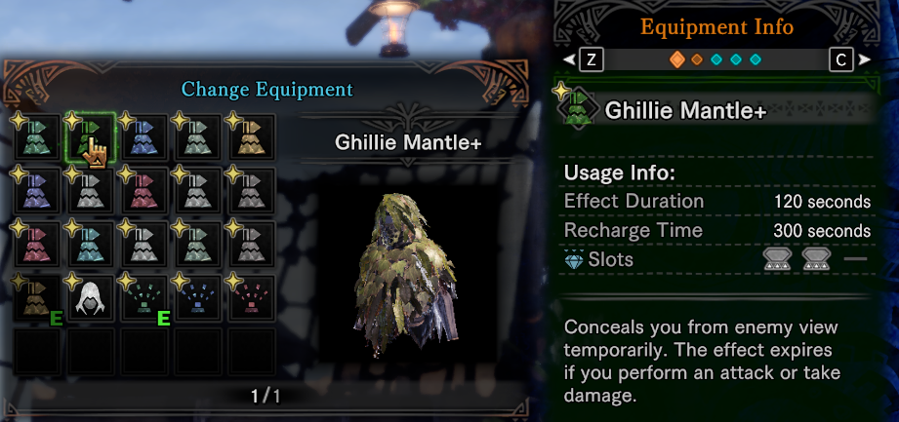

Ghillie Mantle+ and its information

# Strategic – Fighting Strategic – Stun – Monster’s Stun – Parts Stun

***Stun State*** *is contrary to the* ***free state****, in which monsters can’t move and attack freely but immediately interrupt the current action and compulsively engage in fixed behavior.*

* There are plenty of kinds of stuns of 11 levels, and parts stun is in level 2. (The bigger the number the higher the level)
* High level stun will cover low level stun. Same level stuns can cover each other. Same stun can’t cover itself.
* When high level stun is happening, the low level won’t be triggered.
* When many stuns can be triggered in the same time, the highest level stun will be triggered.
* A monster’s all parts have their independent parts stun.
* Parts stun has accumulated value. When value reaches the threshold, the value will be cleared and the stun will be triggered.
* Parts stun’s accumulated value can be accumulated while the stun is happening, but once the value reaches the threshold it will be cleared immediately even if the parts stun isn’t triggered.
* Parts stun has 3 performances: retract, fall to the ground and drool.
* When one part’s parts stun has been triggered several times, the part will be broken.

# Social – Guild Card

*In addition to recording use data,* ***Guild Card*** *also makes it convenient for a player to track and read any players’ user data who he once played together with. The information in guild card could explain a lot of things about the player’s behavior.*

* All data showed in guild card:

1. Basic information: Title, Greeting, ID and Name, Rank, Equipment.
2. Unity, reflects the time of a player spends in multi-player game.
3. Quests Completed, shows the number of quests in different game modes.
4. Weapon Usage, shows the number of weapon used in different game modes, also reflects a player’s proficiency of each weapon.
5. Palico info and Tailraiders, reflects player’s degree of exploration completion in each map.
6. Medals, also called achievements.
7. Arena Records, shows player’s completion time of all arena quests, reflects a player’s hunting skills.
8. Hunting log, shows all monsters’ number of hunted and captured, reflects the player’s familiarity with all monsters’ attack moves.
9. Guiding Lands Research Level.

* Guild Card cannot be viewed and edited when players are in quests.
* Guild Card can be sent to another player in guild card menu or player list menu when you are in a same request or a same online session.
* Guild Cards can be sent and accepted in batches.
* Guild Card can be set to auto-accept and auto-reply. Most players turn on these two function so when a player sends other a guild card he will accept one.
* A player can at most keep 100 other players’ guild card in his guild card list. In list it will also shows other players’ unique unity with the player.
* Guild Cards’ data automatically updates as players go online, instead of staying in the data when you receive the card.